**TATA POWER – ESG , Financial Analysis and DCF Valuation**

Dristi Garg and Rehan Chouhan

Finance Club, IIT Roorkee

Valuation Assignment

7th June, 2024

**Executive Summary**

**Introduction**

The report entails a comprehensive analysis of Tata Power Company's environmental, social, and governance practices, financial performance, and overall valuation. The main purpose is to evaluate the sustainability of the company, its financial health, and the value of its stock using insights and recommendations for the stakeholders.

**Background**

Tata Power is a dominant integrated power company in India. It is engaged in generating, transmitting, and distributing electricity. The company is actively pursuing various renewable energy projects in line with global sustainability goals.

**Key takeaway**

Steady growth in Tata Power's revenue is being achieved year-over-year in response to increasing electricity demand. The net profit margins are declining yet positive when analyzed over a period of past 5 years.

**Analysis**

The company current ratio of about 0.63 and a ratio of debt to equity of 1.5 in the past financial year. It has very strong cash flow generation of 7436 million. Tata Power effectively integrates ESG considerations, and its ratings are high from ESG agencies, though it needs to enhance social impact metrics.

**Table Of Contents**

Page 4 : Description of Company

Page 5 : International Presence

Page 6 : Timeline of the Company

Page 8 : Product Lines

Page 9 : ESG Analysis

Page 16 : SWOT

Page 21 : Growth Trajectory

Page 22 : Future Aspects

Page 24 : Financial Analysis

Page 27 : Competitor Analysis

Page 28: Piotroski Score

Page 29 : DCF Valuation Roadmap

Page 31 : References

**Description of the company**

* The Company has an installed generation capacity of 14110MW in India
* It has presence in all the segments of power sector, viz Fuel & Logistics, Generation (thermal, hydro, solar and wind), Transmission, Distribution and Trading.
* Successful public-private partnership “Tata Power Delhi Distribution Limited” with Delhi Government for distribution in North Delhi.
* It has developed the country’s first 4000 MW Ultra Mega Power Project at Mundra (Gujarat) based on super-critical technology.
* Its international presence includes strategic investments in Indonesia through 30% stake in the leading coal company PT Kaltim Prima Coal (KPC) in Singapore through Trust Energy Resources to securitize coal supply and the shipping of coal for its thermal power generation operations and in Bhutan through a hydro project in partnership with The Royal Government of Bhutan.
* Tata Power now distributes power to the entire state of Odisha

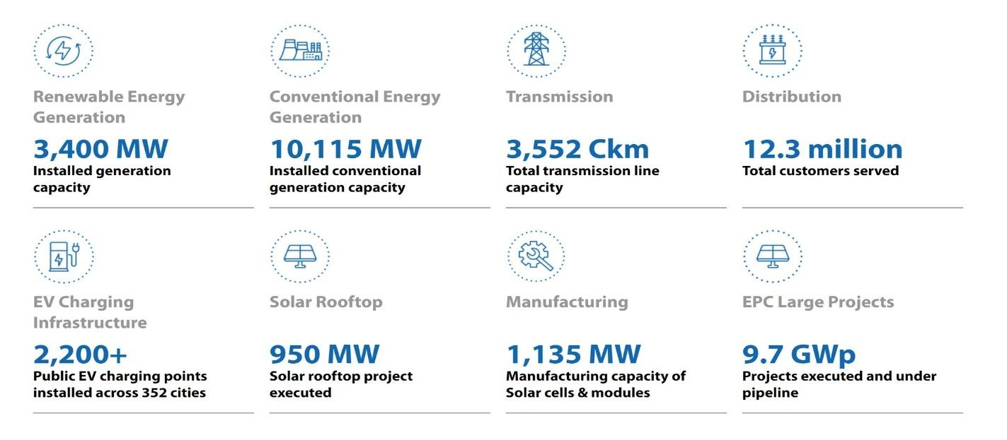

**International Presence**

**Indonesia-** The Company, through its subsidiaries, holds a 30% stake in PT Kaltim Prima Coal (KPC) and a 26% stake in PT Baramulti Suksessarana Tbk (BSSR)

**Singapore: Logistics-** Singapore-based Trust Energy Resources Pte Ltd (TERPL), a wholly owned subsidiary of the Tata Power caters to the shipping requirements of the Company's imported coal-based Mundra Thermal Power Plant at Mundra.

**Bhutan: Hydropresence-** Tata Power has a JV with the Royal Government of Bhutan, under which it has commissioned the 126 MW Dagachhu Hydro Project with Druk Green Power Company.

**Adjaristsqali Georgia LLC** AGL is developing a 187 MW hydropower project (Shuakhevi and Skhalta projects) on the Adjaristsqali River and its tributaries in Georgia.

**120 MW Itezhi Tezhi Hydro Power Project, Zambia**- The Company has commissioned two units of 60 MW each of its 120 MW Itezhi Tezhi hydro Power Project in Zambia, in which Tata Power has a 50 percent stake. The synchronization of both the units was completed in January, 2016. It is currently owned by Tata Power and ZESCO, a Zambian power utility, on a 50:50 basis on a 25 year BOOT (Build-Own-Operate- Transfer) concession term.

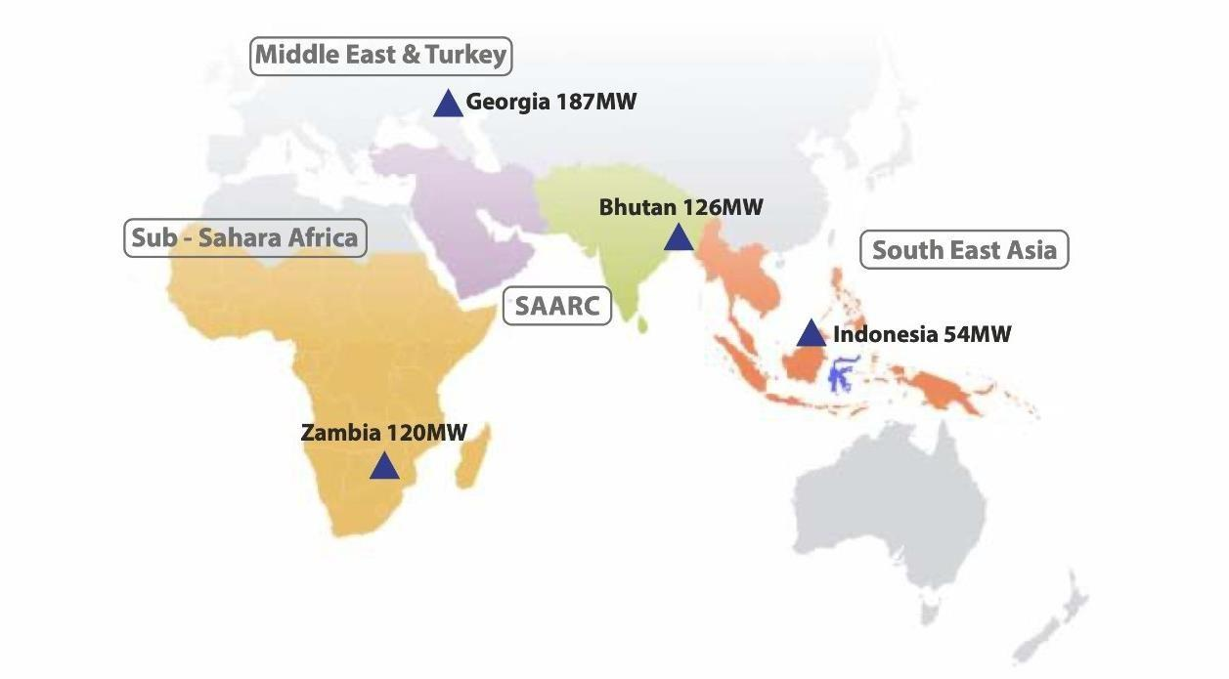

**Timeline of the company**

**1915:** First hydro electric power generating station commissioned at Khopoli with an installed capacity of 40 MW, which was subsequently upgraded to 72 MW.

**1984:** India’s first 500 MW generating unit with multi-fuel burning capability is night commissioned at Trombay.

**2000:** The Tata Hydro-Electric Co. Ltd., The Andhra Valley Power Supply Co. Ltd., and the Tata Power Co. Ltd., are amalgamated to become one entity - The Tata Power Company Limited.

**2003:** Tata Power enters into a joint venture with Power Grid Corporation of India Ltd., to develop a 1200 Km long transmission line to bring electricity from Bhutan to Delhi.

**2013:** Tata Power has implemented the first 4000 MW Ultra Mega Power Project of India at Mundra, Gujarat, based on super critical technology.

**2016:** Tata Power’s Joint-Venture commissions 120 MW Itezhi Tezhi hydro Power Project in Zambia. Tata Power completes 100 years of operation.

**2020:** Jaguar Land Rover India and Tata Power announce partnership for Electric Vehicle charging infrastructure

**2021:** Tata Power now provides power to entire state of Odisha

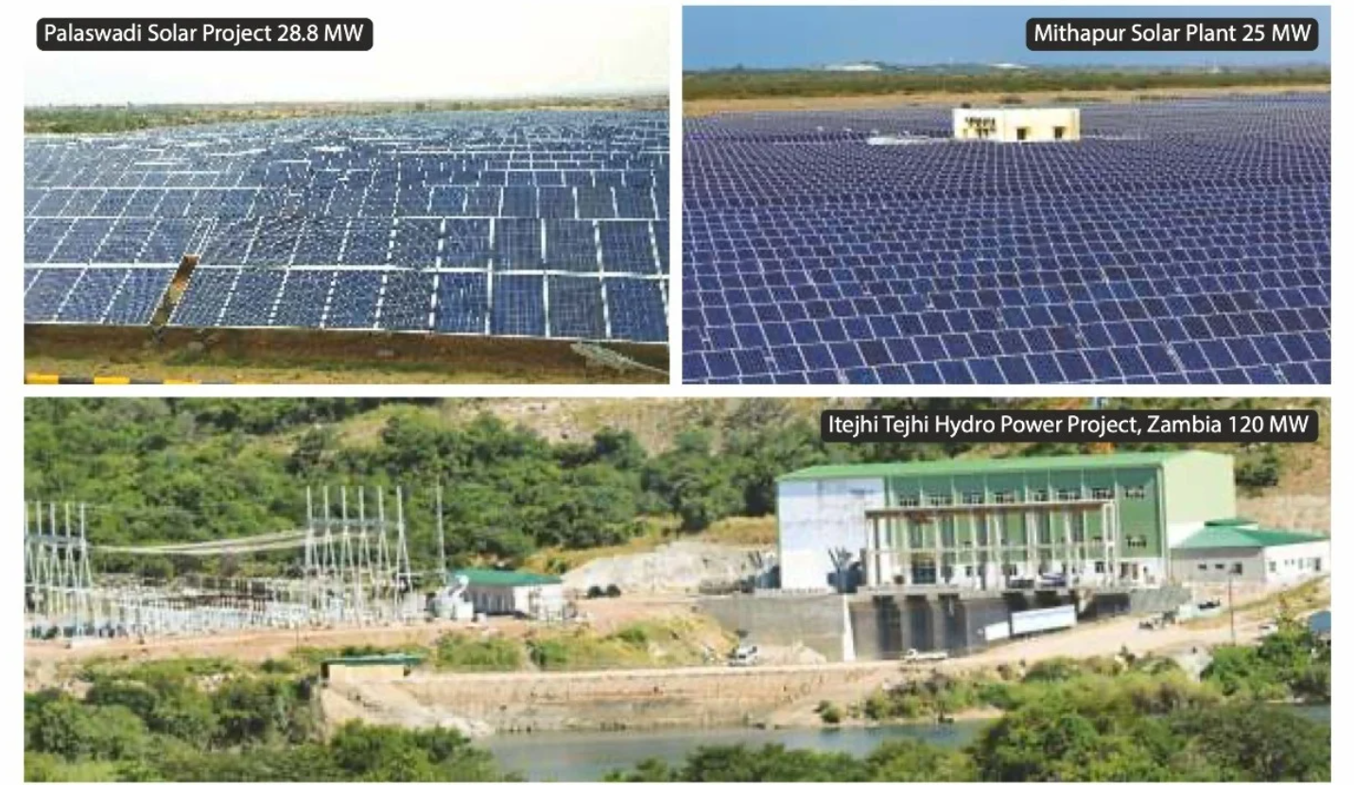

**Product lines:**

* **Harnessing Hydro Power-** It has an installed hydro capacity of **1762 MW.** Through the company’s subsidiaries, **Tata Power Renewable Energy Limited (TPREL), Tata Power Solar Systems Limited (TPSSL) and Walwhan Renewable Energy Limited (WREL**), the company is a front- runner across the renewable spectrum.
* **Harnessing Power of Renewable Energy through Solar Power-** a strong portfolio of **2995 MW** of solar generation capacity. Executed India's first floating solar project for NTPC in Kayamkulam, Kerala.
* **Harnessing Wind Energy-** It installed capacity of **932 MW** and plants spread across five states like Maharashtra, Gujarat, Tamil Nadu, Karnataka , Andhra Pradesh etc.
* **Waste Heat Recovery/ BFG-** Thecompany’sinstalled generating capacity from waste gas generation stands at **443MW**.
* **New and Service-Led** **Businesses**- collaborated with Tata Motors Limited to roll-out EV charging infrastructure. **TP Renewable Microgrid (TPRMG)** is set to roll out **10,000 microgrids** to provide innovative solutions for the under- served communities and expand the global microgrid footprint

**Revenue Composition and Recent Acquisition:**

* **Transmission and Distribution (T&D):** Accounts for around 56% of their total revenue in FY23. This segment involves delivering electricity to end consumers through their distribution network.
* **Generation:** This segment focuses on power generation through various sources including thermal, renewable, and hydro. It contributed around 32% to the total revenue in FY23.
* Here's a breakdown of their revenue by segment for the last year (2023):

1. Transmission and Distribution: ₹345.29 Billion
2. Generation: ₹197.43 Billion (including Renewable and Thermal)

* **February 2024:** Acquired Jalpura Khurja Power Transmission project via a Letter of Intent from REC Power Development for ₹838 Crore.
* **June 2016:** Announced acquisition of a 1,140 MW renewable energy portfolio from Welspun Renewable Energy Private Limited (WREPL). This would make them the largest Renewable Power Company in India.
* **December 2023 (closed):** Resurgent Power, a joint venture with Tata Power Beteiligung (26% stake), acquired a 75.01% stake in Prayagraj Power Generation Company Limited.

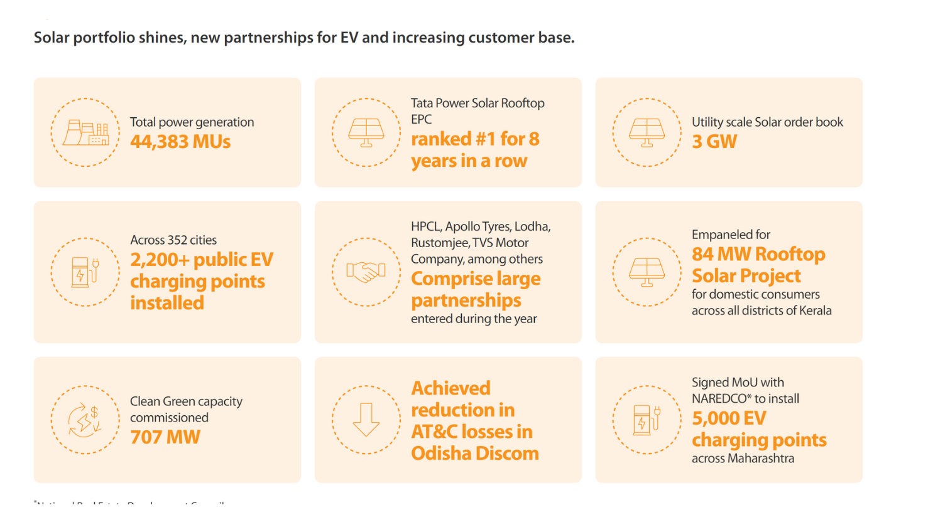

**ESG Analysis**

* Tata Power is one of India's largest integrated power companies, part of the Tata Group, a conglomerate known for its strong emphasis on ethical practices and sustainability. Tata Power operates in various segments, including generation, transmission, distribution, and renewable energy.
* **Environmental**

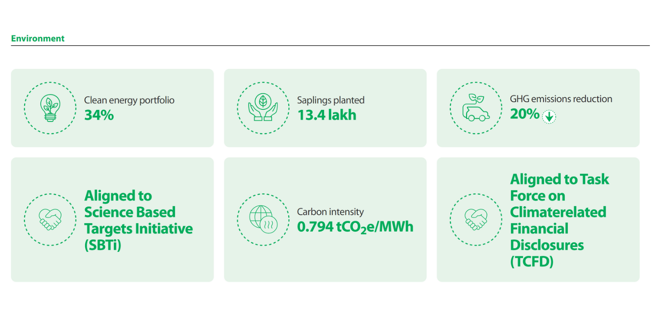

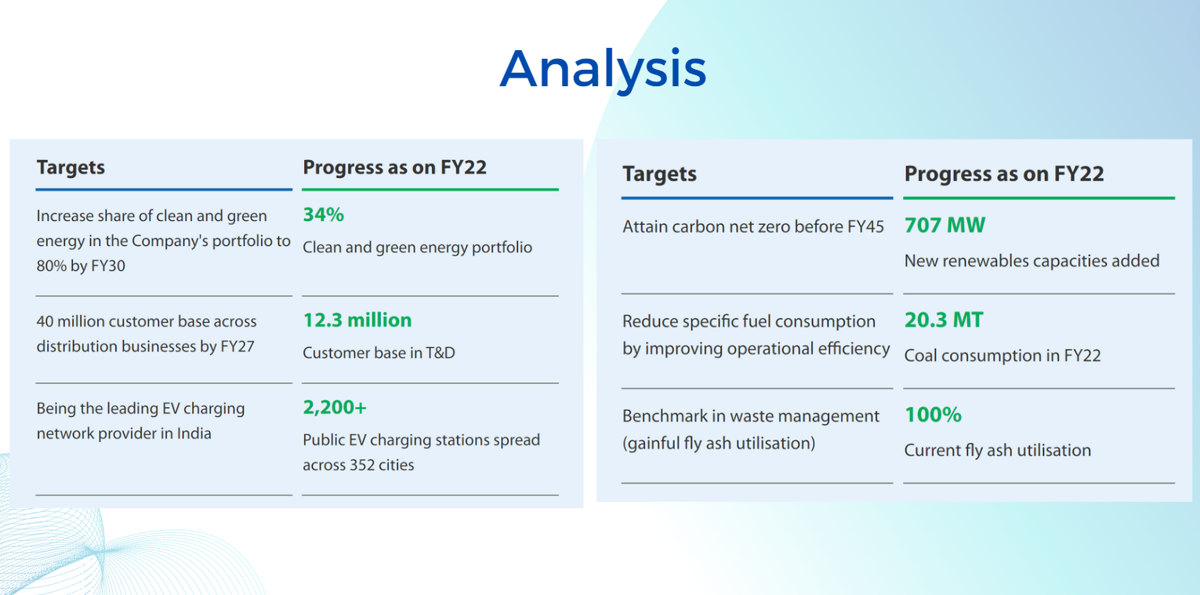

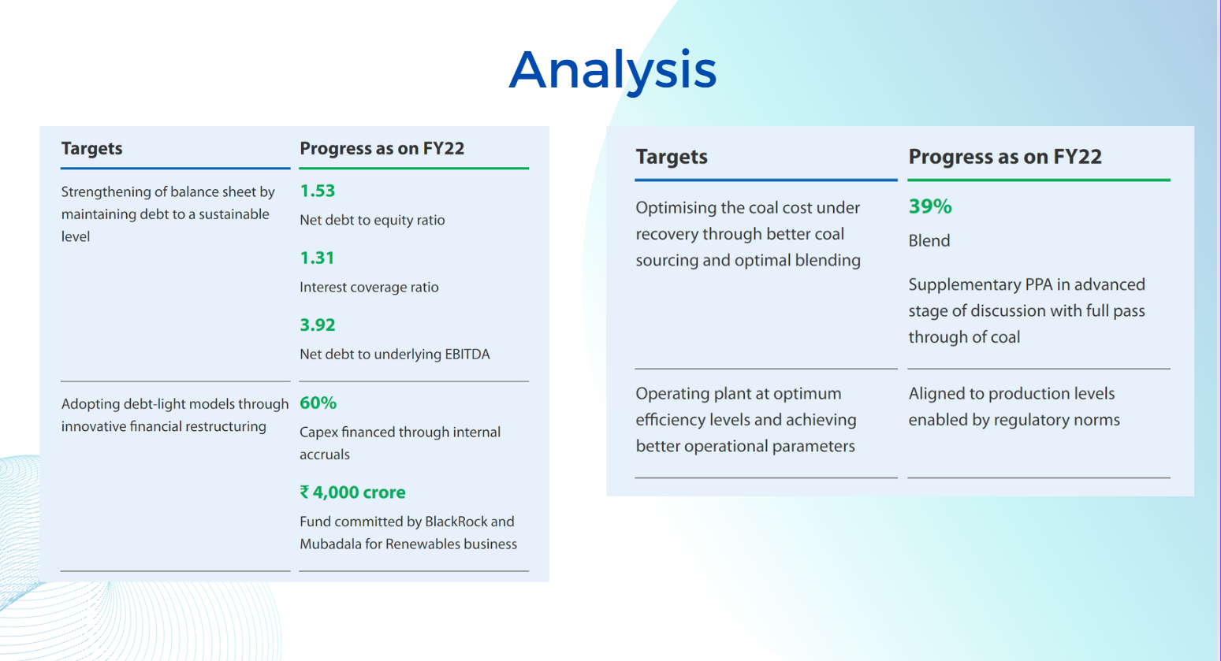

* **Focus on Renewable Energy:** Tata Power has committed to an extremely high percentage of increase in renewable energy capacity. The company has set a target of 50–**60%** of its total generation capacity from renewable sources by 2025.
* **Carbon Footprint, Water Coonsumption Reduction:** The company has taken measures to reduce its carbon footprints by changing to cleaner energy sources and investing in carbon offset projects and 70-90% less water usage for solar and 50-60% less for wind compared to coal.
* **Performance Metrics**: Renewable Energy Capacity: Tata Power, with the most recent reports, has more than 3 GW of renewable energy capacity, with significant investments in solar and wind projects.
* **Areas of Strength:** There is a strong commitment and investment in renewable energy. Comprehensive sustainability reporting and transparency.

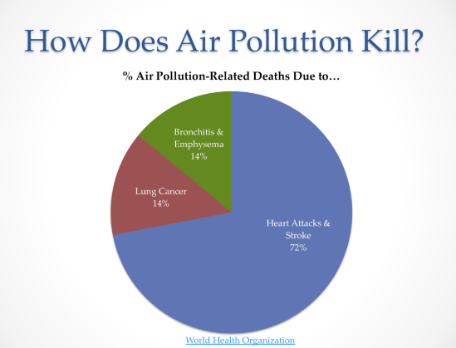

* **Areas of Weakness:** While progress is significant, reliance on coal-fired plants still exists, posing a challenge in fully achieving carbon neutrality. This can lead to a lot of problems in future.

* **Social**
* **Community** **Engagement**: Tata Power engages in various community development programs which focusing on education, healthcare, and livelihood improvements.
* **Employee Welfare**: The company offers extensive employee benefits, including health and wellness programs, training and development opportunities, and initiatives promoting diversity and inclusion.
* **Stakeholder** **Engagement**: Regular meetings with stakeholders, including local communities, investors, and regulatory bodies, to ensure their concerns and suggestions are considered into business practices.
* **Job creation:** 10-15% potential increase in workforce. World Bank claims solar PV and wind energy create about 4-5 jobs per MW of installed capacity
* **Improved Employee Moral:** Sustainability commitments gives a meaning to work employees do hence increasing their happiness and productivity
* **Performance Metrics:** Corporate Social Responsibility (CSR) Spending: Tata Power consistently meets and often exceeds the mandated CSR spending, focusing on impactful community projects. Employee Satisfaction: High employee satisfaction and low turnover rates indicate effective employee welfare programs.
* **Areas of Strength:** Strong CSR initiatives and significant have a positive impact on local communities and people. A lot of employee welfare and engagement programs are held.
* **Areas of Weakness:** There is a need for more structured feedback mechanisms from locals to enhance the impact of CSR initiatives.
* 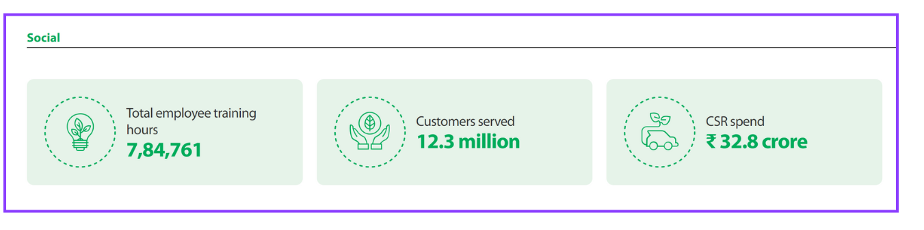
* **Governance**
* **Board Structure**: The board of Tata Power is constituted with diverse, independent directors who ensure effective governance and oversight.

* **Ethical Practice**s: Strong emphasis on ethical business practices, anti-corruption measures, and compliance with regulatory standards.
* **Risk** **Management**: Comprehensive risk management framework, addressing operational, financial, and reputational risks, including those related to ESG factors.
* **Performance Metrics:** Board Independence: High percentage of independent directors on the board. Transparency and Disclosure: Adherence to high standards of transparency and regular disclosures in line with regulatory requirements and best practices.
* **Areas of Strength:** There is a extensive governance structure with a strong emphasis on ethics and compliance. High levels of transparency and stakeholder communication.

* **Areas of Weakness:** While governance practices are strong, there can be improvement by enhancing integration of ESG risks into the broader risk management framework.

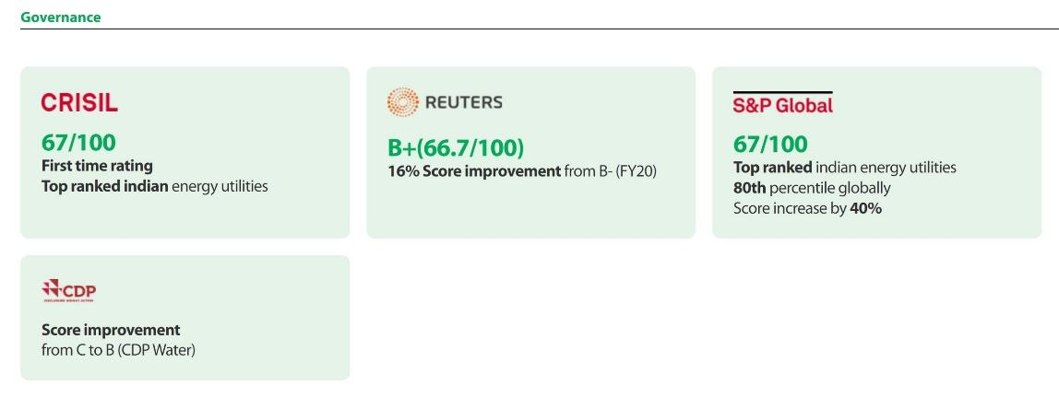

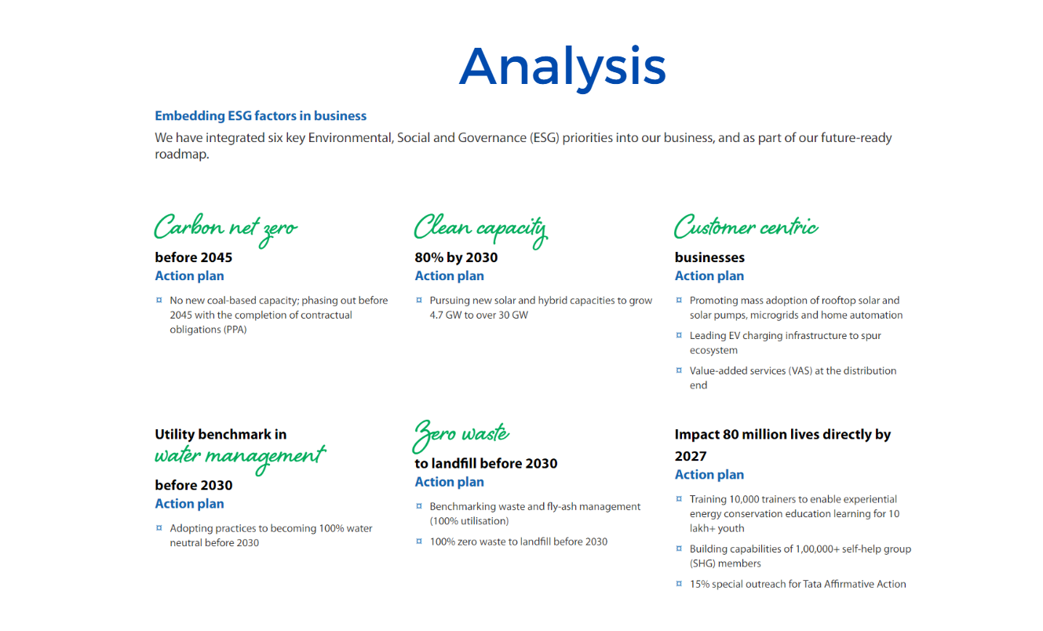

**Recommendations**

* **Accelerate Renewable Energy Transition**: Increase investments in renewable energy projects to reduce dependency on coal-fired plants and achieve carbon neutrality faster.
* **Enhance Community Feedback Mechanisms:** Implement structured feedback systems to better assess the impact of CSR initiatives and make data-driven adjustments.
* **Integrate ESG Risks in Risk Management**: Strengthen the integration of ESG risks into the overall risk management strategy to better anticipate and mitigate potential ESG-related challenges.
* **Increase ESG Training:** Provide ongoing ESG training for employees at all levels to ensure comprehensive understanding and implementation of ESG practices across the organization

**Industry Analysis**

The Indian power industry is one of the most significant sectors for the country's economic growth and development. The same consists of the generation, transmission, distribution, and trading of electricity. The industry has seen significant transformations driven by policy reforms, technological advancements, and increasing demand for electricity due to rapid industrialization and urbanization.

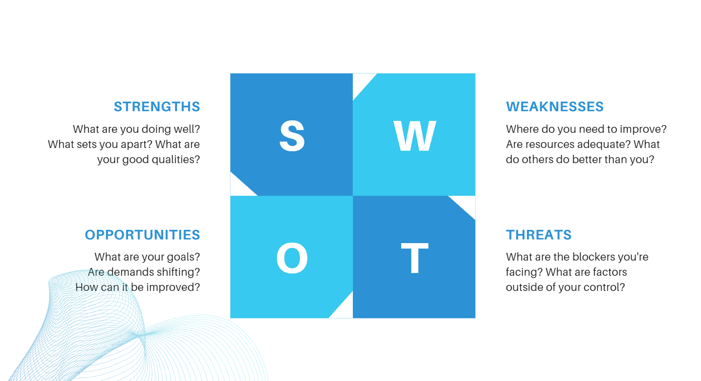

.

* **Strengths:**

1. **Growing Demand:** The increasing urbanization, industrialization, and population growth in India drive the demand for electricity. As more rural areas get electrified and urban areas expand, the need for reliable and continuous power supply surges, creating opportunities for power companies to expand their customer base and increase revenue
2. **Policy Support:** Government initiatives like UDAY (Ujwal DISCOM Assurance Yojana) aim to improve the financial health of state-owned power distribution companies (DISCOMs) by restructuring their debt and enhancing their operational efficiency. Saubhagya (Pradhan Mantri Sahaj Bijli Har Ghar Yojana) focuses on achieving universal household electrification, ensuring last-mile connectivity and increasing electricity demand, thus supporting the growth of the power sector.
3. **Energy Mix:** India's energy mix includes coal, hydro, nuclear, and renewable sources (solar, wind). This diversity ensures energy security by reducing dependence on any single energy source and allows the country to leverage the strengths of each source, such as the reliability of coal and nuclear power, and the environmental benefits of renewables.
4. **Technological Advancements:** Innovations in smart grid technology, energy storage, and renewable energy integration are transforming the power sector. Smart grids enhance the efficiency and reliability of electricity distribution, energy storage solutions provide backup during peak demand, and renewable energy technologies reduce the carbon footprint and operational costs.

* **Weaknesses:**
* **T&D Health:** Despite improvements, T&D losses in India remain high compared to global standards. These losses occur due to technical inefficiencies and theft, leading to significant revenue loss and reduced efficiency in power delivery.
* **Financial Health of DISCOMs**: Many state DISCOMs are financially distressed, with accumulated losses and debt. This affects their ability to purchase power, invest in infrastructure, and maintain reliable services, creating a bottleneck in the power supply chain.
* **Dependence on Coal:** Heavy reliance on coal for power generation poses environmental concerns due to greenhouse gas emissions and air pollution. Additionally, supply risks such as coal shortages or price fluctuations can disrupt power generation and increase operational costs.
* **Regulatory Challenges:** The complex regulatory environment in India, with multiple regulatory bodies and frequent changes in policies, creates uncertainties and delays in project approvals. This complexity can hinder investment, project execution, and operational efficiency.
* **Opportunities:**
* **Renewable Energy:** The Indian government's ambitious targets for renewable energy capacity, such as reaching 175 GW of renewable energy by 2022 and 450 GW by 2030, present significant growth opportunities for power companies. Investments in solar, wind, and other renewable sources are encouraged through incentives and favourable policies.
* **Electric Vehicles**: The increasing adoption of electric vehicles will drive electricity demand and infrastructure development. Power companies can capitalize on this trend by developing EV charging infrastructure, which can lead to new revenue streams and increased electricity consumption.
* **Energy Storage:** The growing importance of battery storage systems to complement renewable energy sources offers opportunities for innovation and investment. Energy storage solutions can help manage peak demand, provide backup during outages, and enhance the reliability of renewable energy
* **Innovations:** The adoption of smart grid technology and the Internet of Things (IoT) for efficient energy management and reduced losses is a significant opportunity. Smart grids enable real-time monitoring and control, leading to improved efficiency, reduced losses, and better integration of renewable energy sources.
* **Threats:**
* **Environmental Regulations:** Stringent environmental norms aimed at reducing pollution and carbon emissions can increase operational costs for power companies, particularly those relying on coal. Compliance with these regulations may require substantial investments in cleaner technologies and emissions control measures
* **Renewable Energy**: The rapid growth of renewable energy can impact the market share of conventional power producers. As renewables become more cost-competitive, there is increased pressure on traditional power companies to transition to cleaner energy sources or risk losing market share.
* **Resource Availability:** Fluctuations in the availability of key resources like coal and gas can affect power generation capacity. Supply disruptions, price volatility, and geopolitical issues can lead to operational uncertainties and increased costs for power companies.
* **Other Risks:** Changes in government policies and regulatory frameworks can impact long-term planning and investments in the power sector. Political instability, policy reversals, and inconsistent regulations can create an uncertain business environment, affecting investor confidence and strategic decisions.

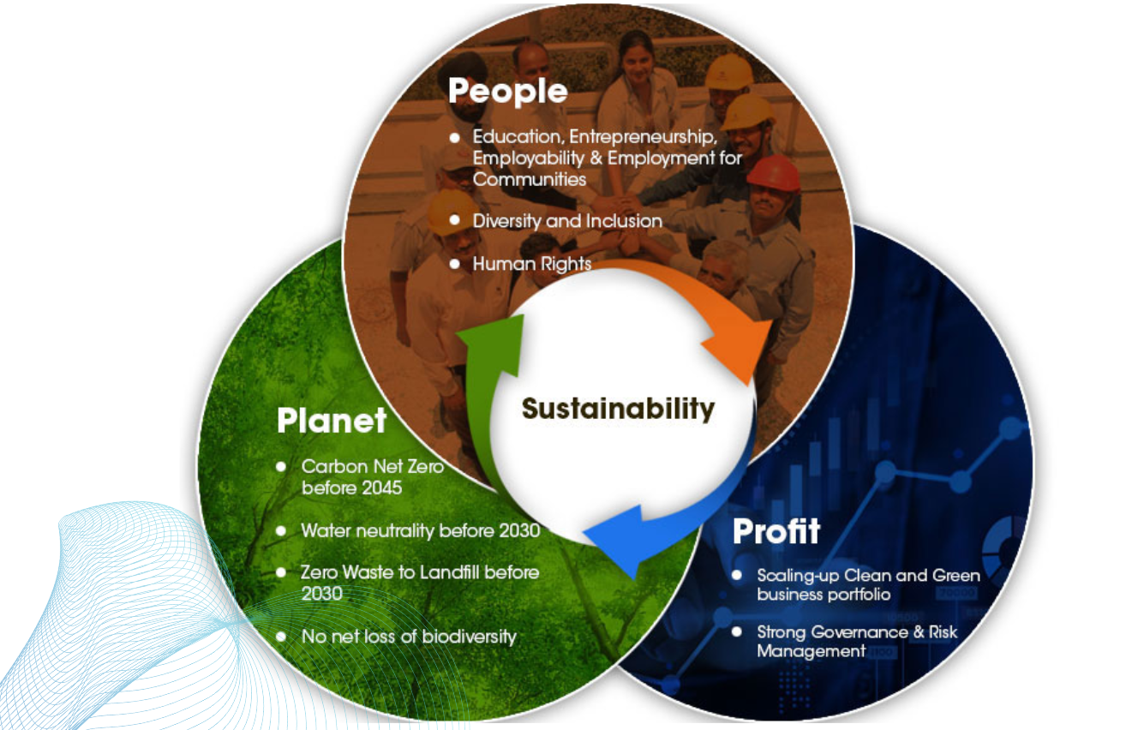

**Growth Trajectory**

* Over the past two decades, the Indian power sector has experienced substantial growth driven by economic development, increased industrial activities, and rising population. The installed power capacity has expanded significantly, with a notable shift towards renewable energy sources.

* The sector has seen major policy reforms aimed at improving efficiency, increasing capacity, and ensuring energy security. Initiatives like the Electricity Act 2003, National Electricity Policy, and various renewable energy policies have been instrumental in shaping the growth trajectory.
* As of 2024, India’s installed power capacity stands at around 400 GW, with renewables (solar, wind, hydro, and biomass) accounting for approximately 38% of the total capacity.
* The power sector continues to be a key focus area for the government, with ongoing efforts to enhance grid reliability, reduce losses, and promote sustainability.

**Future Prospects**

* **Renewable Energy Expansion:** India aims to achieve 450 GW of renewable energy capacity by 2030, with substantial investments in solar and wind energy projects driving this growth.
* **Electric Vehicles (EVs) and Charging Infrastructure:** The adoption of electric vehicles is expected to surge, driven by environmental concerns, government incentives, and advancements in EV technology.
* **Energy Storage Solutions:** The development and deployment of advanced battery storage systems are critical for managing the intermittency of renewable energy sources, providing grid stability, and supporting off-grid applications.
* **Rural Electrification and Microgrids:** Continued efforts towards rural electrification and providing reliable power supply to remote areas will drive demand, with microgrids and distributed generation systems playing a crucial role.
* **Environmental and Regulatory Landscape:** Increasingly stringent environmental regulations will push the industry towards cleaner and more efficient energy sources, necessitating investments in clean technologies and emissions reduction strategies.
* 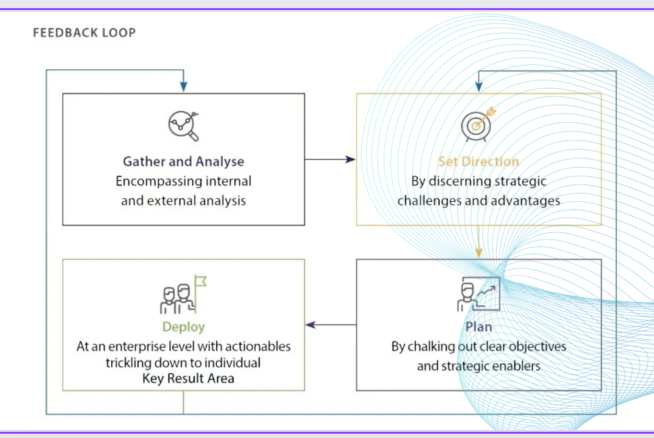

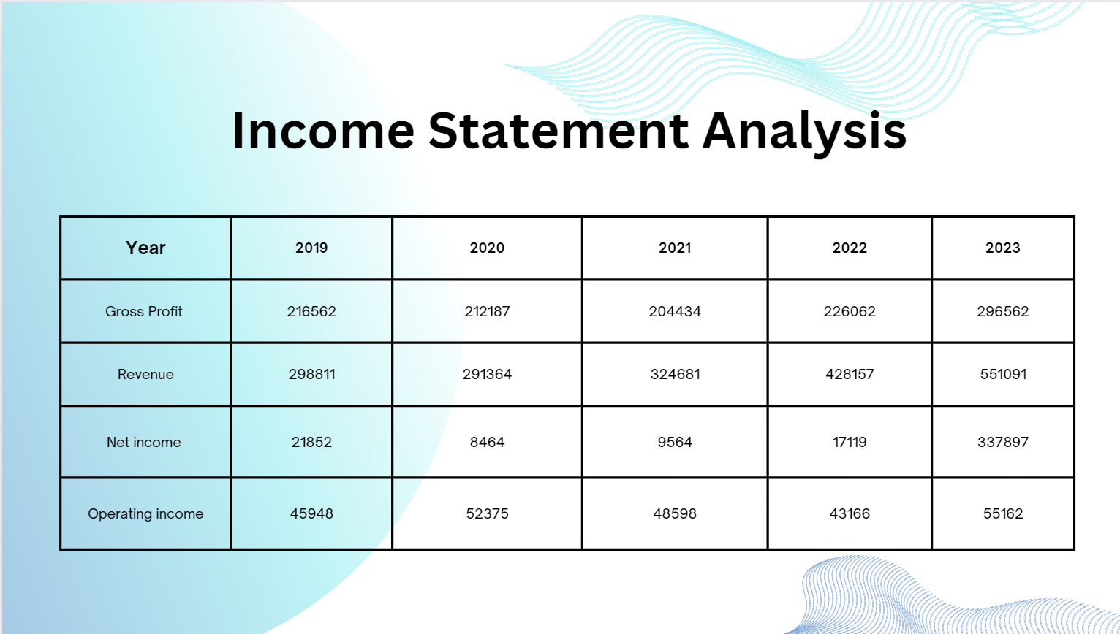

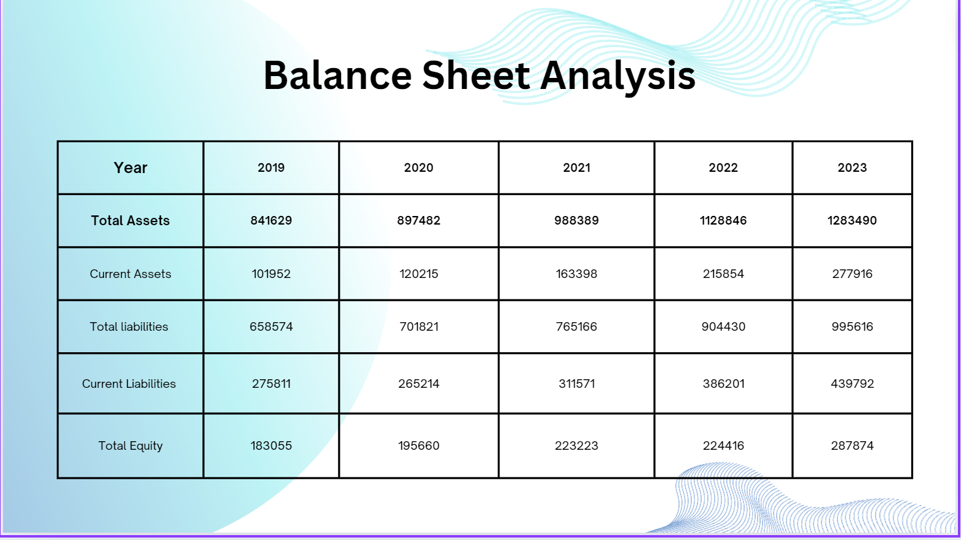

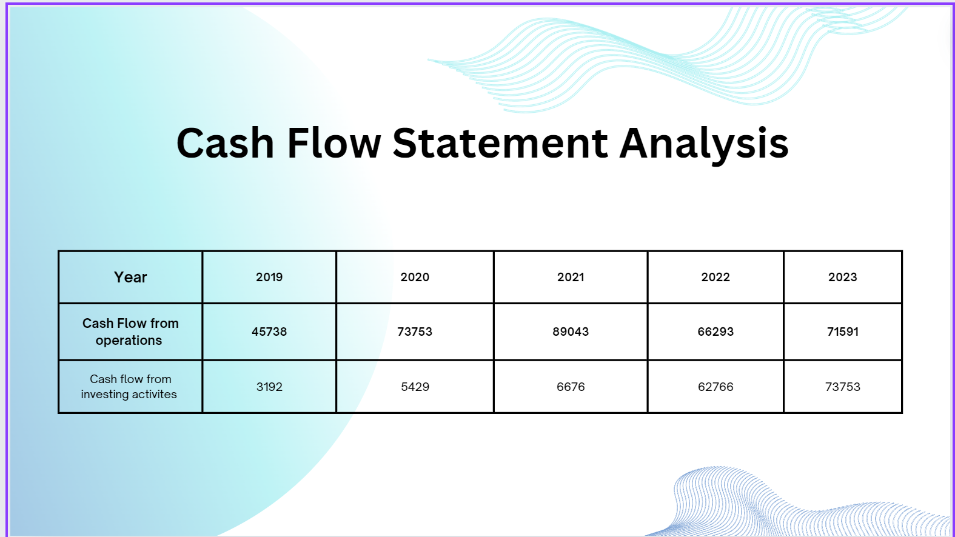

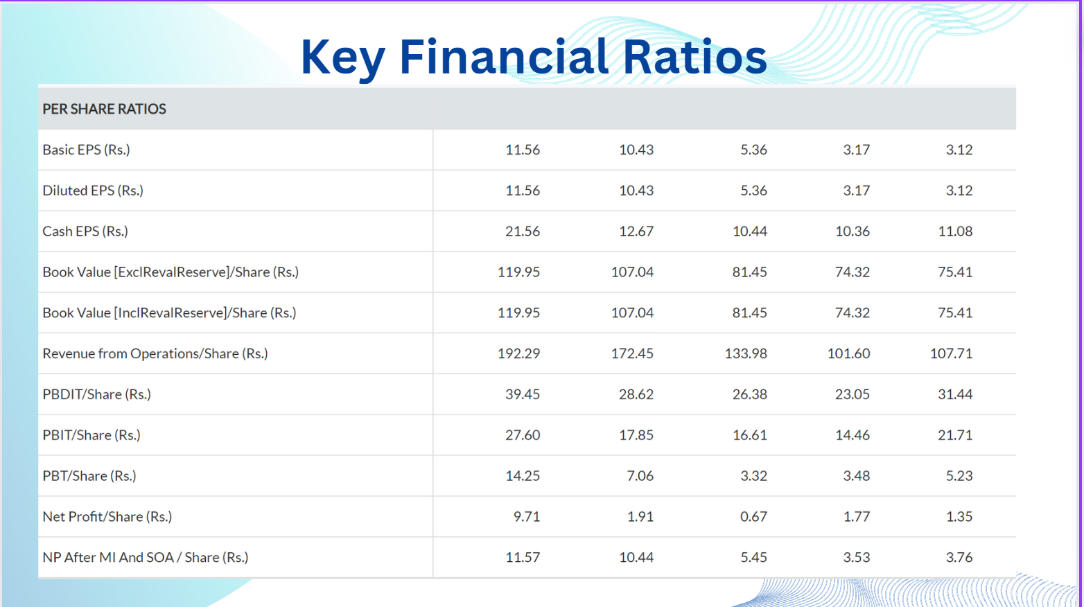

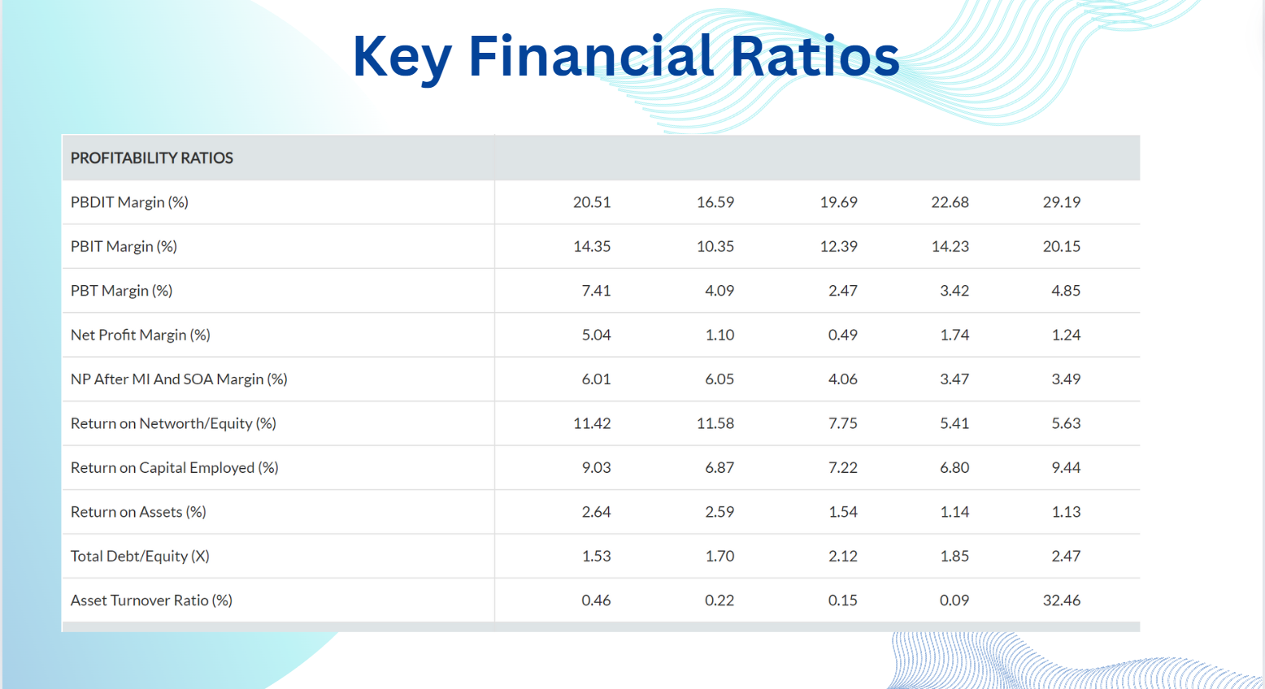

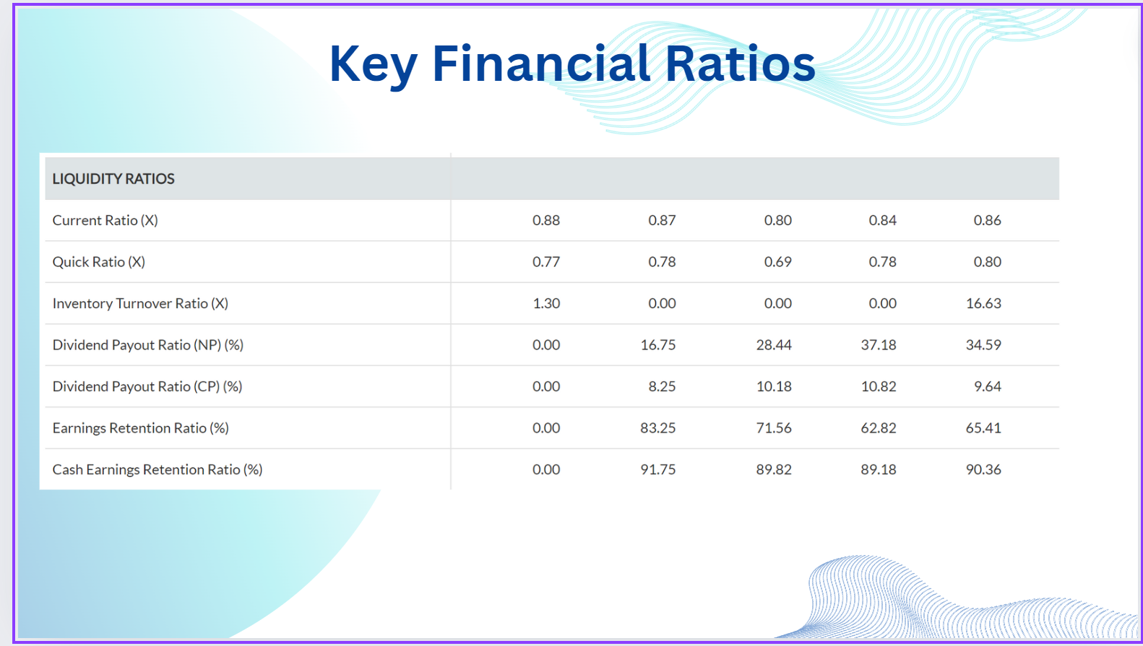

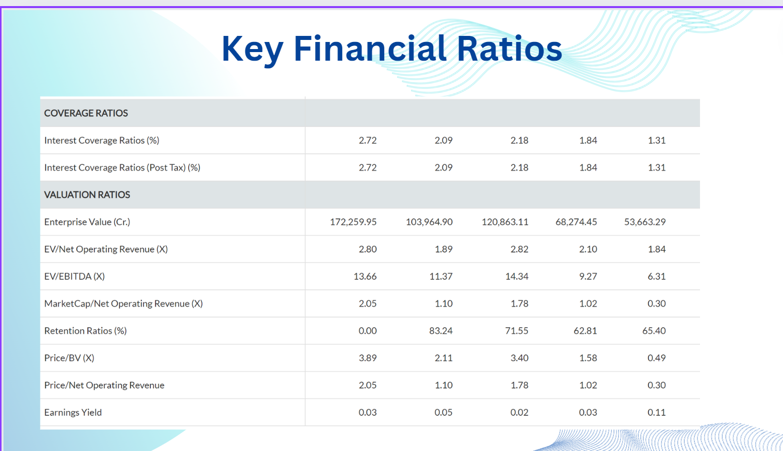

**Financial Risks and challenges**

* **Liquidity Risk:** The low current ratio indicates a potential inability to meet short-term liabilities, which could lead to solvency issues.
* **Leverage Risk**: The high debt to equity ratio indicates significant reliance on debt, increasing the risk of financial distress if the company’s earnings decline or interest rates increase.
* **Asset Utilization**: The relatively low asset turnover ratio suggests inefficiency in using assets to generate revenue. This may require strategic adjustments to improve asset utilization.
* **Sustainability of Profit Margins:** While high profitability margins are beneficial, sustaining such high levels may be challenging. It’s important to ensure these margins are not due to one-time events or unsustainable practices.

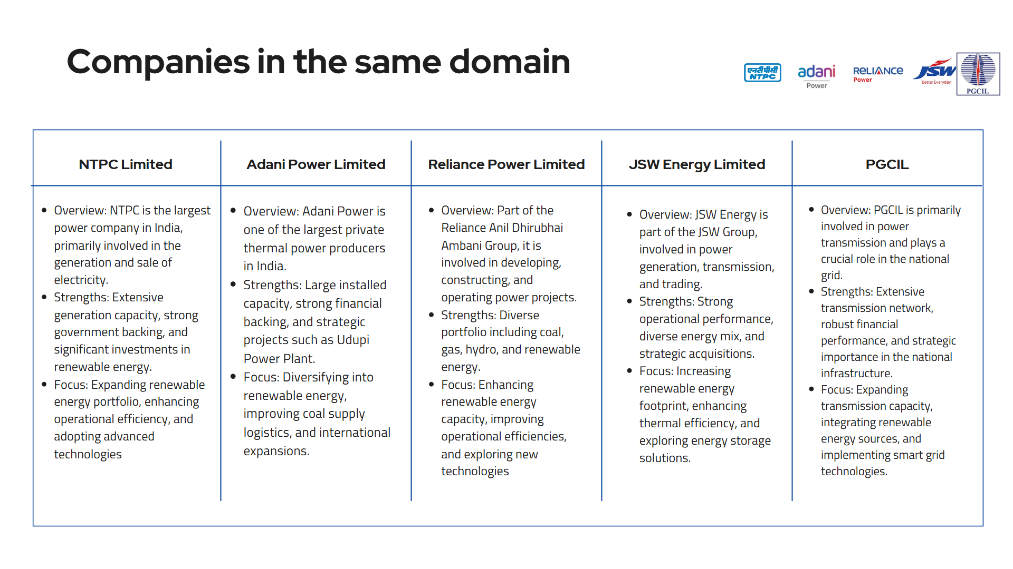

**Piotroski Score**

The Piotroski score is a discrete score between zero and nine that reflects nine criteria used to determine the strength of a firm's financial position. The Piotroski score is used to determine the best value stocks, with nine being the best and zero being the worst. The nine aspects are based on accounting results over a number of years; a point is awarded each time a standard is met, resulting in an overall score.

**1. Profitability Criteria:**

* Positive net income (1 point)
* Positive return on assets (ROA) in the current year (1 point)
* Positive operating cash flow in the current year (1 point)
* Cash flow from operations being greater than net Income (quality of earnings) (0 point)

2.**Operating Efficiency criteria**

* A higher [gross margin](https://www.investopedia.com/terms/g/grossmargin.asp) compared to the previous year (1 point)
* In the year 2022, the gross margin is 52.7%.
* A higher [asset turnover ratio](https://www.investopedia.com/terms/a/assetturnover.asp) compared to the previous year (1 point).
* In the year 2022, it is 37.92%

3.**Leverage, Liquidity, and Source of Funds Criteria**

* Lower amount of [long-term debt](https://www.investopedia.com/terms/l/longtermdebt.asp) in the current period, compared to the previous year (decreased leverage) (1 point)
* Higher [current ratio](https://www.investopedia.com/terms/c/currentratio.asp) this year compared to the previous year (more liquidity) (1 point)
* in 2022, it is 0.5582.
* No new shares were issued in the last year (lack of dilution) (1 point).

Piotroski F Score = 8

**DCF Valuation Roadmap**

1. In the first sheet, to calculate free cash flows from 2020-2023 by using the appropriate formula, we have listed some important financial metrics such as Revenue, Effective Tax Rate, EBIT, Non-Cash WC etc.

FCF= EBIT(1-T) + D&A – CapEx – change in Non-Cash WC

1. In the second sheet, we’ve done the WACC calculation.

* Risk Free Rate = r =10 yr Bond Rate – Indian DS = 6.69% - 2.69% = 4.27%
* Cost of Debt = r + ¾(CDS of India) + Company DS

Here ¾ measures how much the company is affected by the risk in Indian Markets.

For company DS we calculate Interest Coverage Ratio (EBIT/Interest Expense) and then we use the table <https://pages.stern.nyu.edu/~adamodar/New_Home_Page/datafile/ratings.html>

* For beta we use the relation b/n levered and unlevered beta and we took unlevered beta from <https://pages.stern.nyu.edu/~adamodar/New_Home_Page/datafile/Betas.html>

Levered beta = Unlevered beta*(1+(1-T)*D/E) where T is corporate Tax Rate

* For Cost of Equity we used CAPM formula for which ERP or market risk premium is calculated by taking a revenue weighted average of the company in different countries, ERP for India=7.81%
* Then after calculating the weighted average of Market Cap and Debt, we use WACC formula, WACC = 7.53% = Weighted average of cost of capital

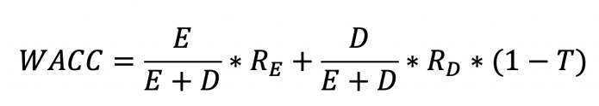

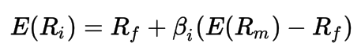

1. In the 3rd sheet, we used Perpetual Growth Method for Terminal Value, in this we estimated the Terminal Growth Rate to be the average of long term inflation rate and the GDP growth rate because it lies b/n both of them. (This was conveyed in the lectures). Terminal Value = 637527.11 Cr INR

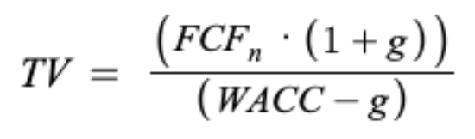

1. In the final sheet, we show the working of DCF model for a 10yr maturity period

We also projected some metrics so as to calculate FFCFs

* The Revenue Growth Rate shall converge at risk free rate at the end of 10 yr period and for initial future years, it grows at CAGR of 2020-2023
* Similarly Tax Rate converges at Marginal Tax Rate at the end
* For Expense % projection, we assume that its equal to the average of 2020-2023
* For OM Growth % we assume that it converges at average of 2020-2023
* Other variables used in FFCF formula are projected using inter-related formulas including above variables
* Enterprise value = NPV of all future cash flows + Terminal Value
* Equity value = Enterprise value + cash and cash equivalents of 2023 – Total Debt of 2023
* Share Price = Equity Value / no. of outstanding shares

**CONCLUSION :** Our implied share price = 860 INR whereas the current share price equals 433.55 INR hence it is undervalued by 48.42%

For investors looking for short term gains this may not prove to be fruitful as undervalued stocks need time to show their true worth. However, if you are a patient investor who has done exhaustive research and believes in the fundamentals of a business, then investing in undervalued stocks could be a rewarding experience because they will approach their Intrinsic/true value & hence assuring profit.

**References**

<https://www.tatapower.com>

<https://www.tatapower.com/investor-relations/tata-power-2023/pdf/Consolidated_Accounts.pdf>

<https://www.tatapowerrenewables.com/pdf/annual-report-fy-23.pdf>

<https://www.moneycontrol.com/india/stockpricequote/power-generationdistribution/thetatapowercompany/TPC>

<https://pages.stern.nyu.edu/~adamodar/New_Home_Page/datafile/Betas.html>

<https://pages.stern.nyu.edu/~adamodar/New_Home_Page/datafile/ratings.html>

https://www.investopedia.com/terms/t/terminalvalue.asp#:~:text=Terminal%20value%20is%20calculated%20by,value%20after%20the%20forecast%20period.